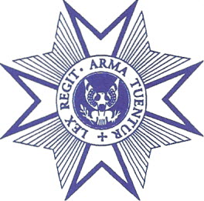
FOUNDED 1865
THE MILITARY ORDER OF THE LOYAL LEGION OF THE UNITED STATES
COMMANDERY OF THE STATE OF PENNSYLVANIA
Commandery Registrar’s Report
Pennsylvania Commandery Business Meeting
6 June 2017

To the Governing Board:

At this time, please be advised that I am submitting membership applications from the following candidates:

Hereditary

William Rutherford Firth, III
Chester Springs, Pennsylvania
By right of collateral descent from 1st Lt. John R. Nice, Company H, 99th Pennsylvania V.I.
Killed in Action, Gettysburg, Pennsylvania, 2 July 1863

Alexander Barton Gray
Arlington, Virginia
By right of direct descent from Capt. Duane Merritt Greene, Company E, 6th California V.I.,
2nd Lieutenant, Company C, 3th U.S. Infantry, and Company L, 6th U.S. Cavalry

Ambassador Michael Brackett Smith
McLean, Virginia
By right of collateral descent from Regimental QM & 1st Lt. Alexander H. Ricker, Company H, 91st Ohio V.I., Captain, Company D. 2nd West Virginia Cavalry, Staff officer to Brig. Gen. A.N. Duffie

Capt. Christian M. Smith, USMC
Annapolis, Maryland
By right of collateral descent from Regimental QM & 1st Lt. Alexander H. Ricker (see above)

Brian Lewis Kerns
Alexandria, Virginia
By right of collateral descent from 2nd Lt. Henry Eckenroth, Company E, 124th USCT
[Please note: Mr. Kerns is already a member, but his original qualifying ancestor proved to be in error; his brother Scott Kerns submitted a corrected application for our March meeting, which was approved. Likewise, Mr. Kerns has submitted a replacement short-form application]

Michael Scott Lewis Kerns
Alexandria, Virginia
By right of collateral descent from 2nd Lt. Henry Eckenroth, Company E, 124th USCT
Same as above, however, this application was never approved by the Registrar-in-Chief due to the qualifying ancestor issue; a corrected short-form application is being submitted

Associates

Noah Edward Meyers Kyle Lee Miller Daniel J.F. Lupia
Washington, D.C. Mechanicsburg, Pennsylvania Harrisburg, Pennsylvania

I am pleased to announce that we now have a final version of the MOLLUS promotional video, which will have its first viewing by the membership during the June 6 meeting. Afterward, the video can be uploaded onto our YouTube channel, and a link can be posted on social media and forwarded to any individual email. Our videographer, Amanda Stevenson, has done remarkable work, and we should all be pleased with her fine efforts.

There are now 11 playlists on the MOLLUS YouTube channel, featuring archival movie footage, documentary clips and newsreel highlights regarding original & famous companions, Civil War veterans’ reunions, President Lincoln and much more. Since last year, we have added a playlist on Civil War battles, and we have uploaded the videotaped address of Dr. Allen Guelzo which was given at the annual congress in Gettysburg last October. Cumulative views of the playlists & video now exceed 1,000.

Finally, please be advised that the date for the Commandery summer picnic has been set for Saturday, July 28, 2017, at 4:30 p.m., at the residence of the Commandery Registrar in Wenonah, New Jersey. The evening will start with cocktails & socializing, after which dinner will be served. The following menu is set thus far, similar to last year: smoked bistro filet, barbecued chicken, roasted asparagus, salad, rolls and fresh fruit. The anticipated cost will be $35 per person, $15 for children. All are invited, although we will probably be limited to around 45-50. Invitations will be sent shortly.

Respectfully submitted,

_s/________________
Paul J. Lader, Esq.
Registrar, Pennsylvania Commandery

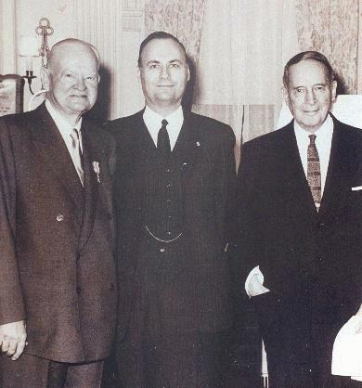

“MOLLUS is the noblest of the American hereditary orders.”
--General Douglas MacArthur (Insignia No. 15317), 1961

